Contact Information
James Barrett, Assistant Director of Housing
Phone: 715-343-7142
Email: jbarrett@capmail.org
May 4, 2022
FOR IMMEDIATE RELEASE

Donate A Truck to CAP Services' Housing Rehab Program!
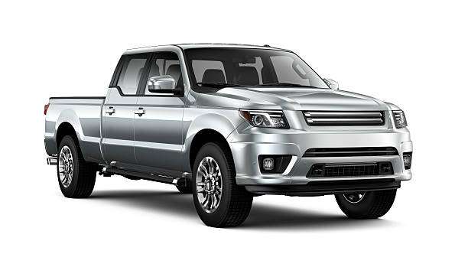
Do you have a mid-size or full-size pickup with four doors that you can donate to CAP Services? Contact James Barrett at jbarrett@capmail.org to discuss. The vehicle should be no more than 10 years old and have less than 100,000 miles. Manual or automatic accepted. Air conditioning and 4WD preferred.
CAP's Housing Rehab Program provides income-eligible homeowners with loans and grants to make necessary repairs to maintain the integrity, stability and safety of their home. Households with less income have a harder time paying for repairs without CAP's help. The longer repairs are deferred, the more costly the repairs become. Common issues include leaking roofs, non-working furnaces, inefficient windows, damaged siding or flooring, electrical and plumbing, and/or paint stabilization and lead hazard reduction.
Staff must drive to clients' homes in Wood, Portage, Waushara, Marquette, and Waupaca counties to inspect properties and repairs. They are currently driving a 2WD truck without air conditioning that is 18 years old and has over 217,000 miles on it! Current funding cannot be used for capital purchases like a new truck, so CAP needs your help. Donate a vehicle so that CAP can continue to provide families with services that help them maintain their home, which is often their greatest asset.

CAP Services, Inc. is a private, nonprofit community action agency that has been advancing social and economic justice for people and communities in Marquette, Outagamie, Portage, Waupaca and Waushara counties since 1966.
###

